Walmart’s Customer Satisfaction in Electronics & Home Entertainment

Michelle Valencia | Joseph Aytch | Lauren Furman | Eliana Alon

Bellevue University

September 24, 2024

Table of Contents

Introduction 3

Business Problem/Hypothesis 3

Methodology 4

Analysis & Results 5

Recommendations/Ethical Considerations 9

Recommendations 9

Proposal: Electronics Home Entertainment Experience Platform (EHEEP) 9

Ethical Considerations 10

Conclusion 11

References 11

Appendix 11

# Introduction

Walmart has long been a dominant force in the retail industry, offering a wide variety of products at competitive prices. As consumer demand for electronics and home entertainment products continues to grow, Walmart has expanded its offerings in this category, providing customers with affordable yet high-performing options for devices such as TVs, smartphones, and gaming consoles. However, with an extensive range of electronics, Walmart faces the challenge of maintaining high levels of customer satisfaction across these diverse product lines. Understanding the factors that influence customer satisfaction is essential for Walmart to stay competitive and continue meeting customer expectations.

This project aims to analyze Walmart’s customer satisfaction in the electronics and home entertainment category using consumer review data. By examining sentiment, product ratings, and the impact of factors such as pricing, demographics, and promotions, we will generate actionable insights that can help Walmart enhance customer satisfaction and better tailor its electronics offerings to customer needs.

# Business Problem/Hypothesis

**Business Problem**

The electronics market is highly competitive, with customers expecting not only high-quality products but also cutting-edge technology at competitive prices. Walmart must identify key areas where customer satisfaction in its electronics and home entertainment offerings can be improved to stay competitive. The main challenge lies in understanding which factors—such as product price, quality, durability, promotions, and customer demographics—most significantly affect customer satisfaction.

Additionally, Walmart needs insights into how satisfaction levels differ across various electronics categories, such as televisions, smartphones, laptops, and gaming consoles, to make informed decisions about product development, inventory management, and customer engagement strategies.

**Hypothesis**

We hypothesize that:

1. **Higher-priced electronics** such as smart TVs and gaming systems will have higher satisfaction levels compared to lower-cost items like basic headphones or phone chargers.
2. **Demographic factors**, including age and location, will significantly impact customer satisfaction, as different groups may prioritize factors like price, performance, or brand reputation differently.
3. **Discounts and promotions** on electronics will positively affect customer satisfaction, particularly during sales events or product launches, though the impact may vary depending on the product category.
4. **Sentiment analysis** of customer reviews will reveal key themes such as product performance, battery life, screen quality, and technical reliability as the most frequently mentioned topics in customer feedback.

# Methodology

The data was obtained from data world ([link here](https://data.world/promptcloud/walmart-product-listing-data-2020/workspace/file?filename=marketing_sample_for_walmart_com-walmart_com_product_reviews__20200101_20200331.zip)) and stored in a CSV format. The data contains several columns including title (or product description), the review itself, the rating the review gave, and overall stars given. There were also some supplemental columns like the amount of upvotes a review was given to identify popular sentiments. The rest of the columns were not as useful and thus are not displayed.

Next, we extracted the dataset with python and removed any rows that lacked a review, since we wanted to perform sentiment analysis on the reviews themselves. Next, we used a tool called VADER (Valence Aware Dictionary and sEntiment Reasoner) to figure out whether each review expresses a positive, negative, or neutral feeling. This is done automatically by looking at the words and phrases used in each review. VADER automatically ignores words like the, and, etc., so we can get some actual valuable insight. We also ignored any words that appeared 5 times or less to reduce the amount of strange, unhelpful words or typos. The code also allows for a custom number of top words to be displayed, for the sake of this analysis, 30 words were chosen as positive and negative reviews could potentially have many similar words, especially since all the products are electronics. The code also displays how many reviews fell into each category.

We also performed some Exploratory Data Analysis on the data after it was cleaned up to allow us to gain more insight and draw more conclusions from the data. We dug into the data a little more by brainstorming some potential stakeholder ideas and manipulating the data to show some potential insights into what the answers could be. Less visualizations were used as the data is mostly words and harder to display on a graph. The main tool used was pandas as it allows us to create and manipulate datasets that can also be extracted and used in Excel or elsewhere if needed. It also allows us to group and organize the data as needed.

# Analysis & Results

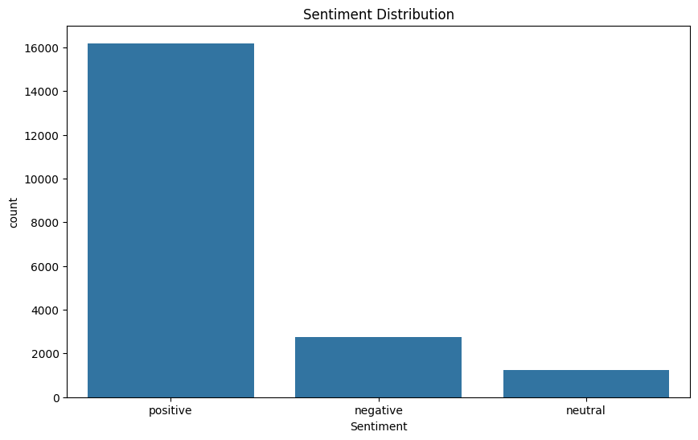

As we can see from the sentiment distribution, most of the reviews were positive. This is good news for the stakeholders as it means most of the products are being held in positive regard. 16,190 out of 20,184 reviews have positive sentiments according to the VADER sentiment analysis tool that was used, so about 80%. Now let’s look at the sentiment distribution in a little more detail.

In order to get a fuller grasp of the key words, we chose to show the top 30 words for positive, neutral, and negative sentiments.



In terms of positive, a number of words stand out. TV and Phone seem to be the main products being bought and/or reviewed, as one would likely surmise given the electronic nature of the dataset. “Easy” and “Use” are two top words, so ease of use is likely something that consumers want in a product. “Sound” and “Picture” were not as high but still often mentioned, meaning that people care about sound and picture quality almost as much as they do about ease of use. “Price” and “Quality” imply people want a good bang for their buck. “Better” could imply that people are looking to replace previous products. Another interesting occurrence is “Roku”, meaning that a lot of Roku products have positive sentiments connected to them. With that information Walmart could look to ensure they continue to have Roku products stocked. In conclusion, ease of use, quality of product, and fair price can be some potential themes for positive sentiment linked products, and Roku products seem to have the most of these occurrences.

In terms of negative, many words stand out as well. “Work” is one, implying products not working correctly was a big reason for negative reviews. “Sound”, “Screen”, and “Battery” also were highly recurring, implying that the lack of quality in these cases are the cause of many negative reviews. “Disappointed” was up there so expectations for products are not being met for these products. We don’t see a name of a company in the top words so we can’t pinpoint a problem manufacturer from these keywords. In essence, we can surmise that TVs and phones with poor sound, screen, and/or battery quality are the cause of many of these negative reviews.

If we dig deeper down the list, we could likely find some other themes. “Watch” for instance is in the low 20s for positive and negative, so that can be concluded to be the third highest product bought behind TVs and Phones. Most conclusions could be drawn if we looked at more, but for the sake of time we stuck with 30.

Next we looked at the most popular products and their ratings.



From this chart, we can see that Roku products top the list of most purchased products, usually streaming devices or streaming players. This affirms the previous conclusion that Roku products have the most positive sentiments tied with them. They all also have a mean rating of 4+, meaning that the vast majority of reviews are positive. Interestingly, the only two products on this list with ratings before 4 are RCA products, so perhaps that can give some insight into which company’s products are the most floundering. It can also give some answers as to whose products should be stocked more or less.

Finally, let’s take a look at the most upvoted reviews, positive and negative.

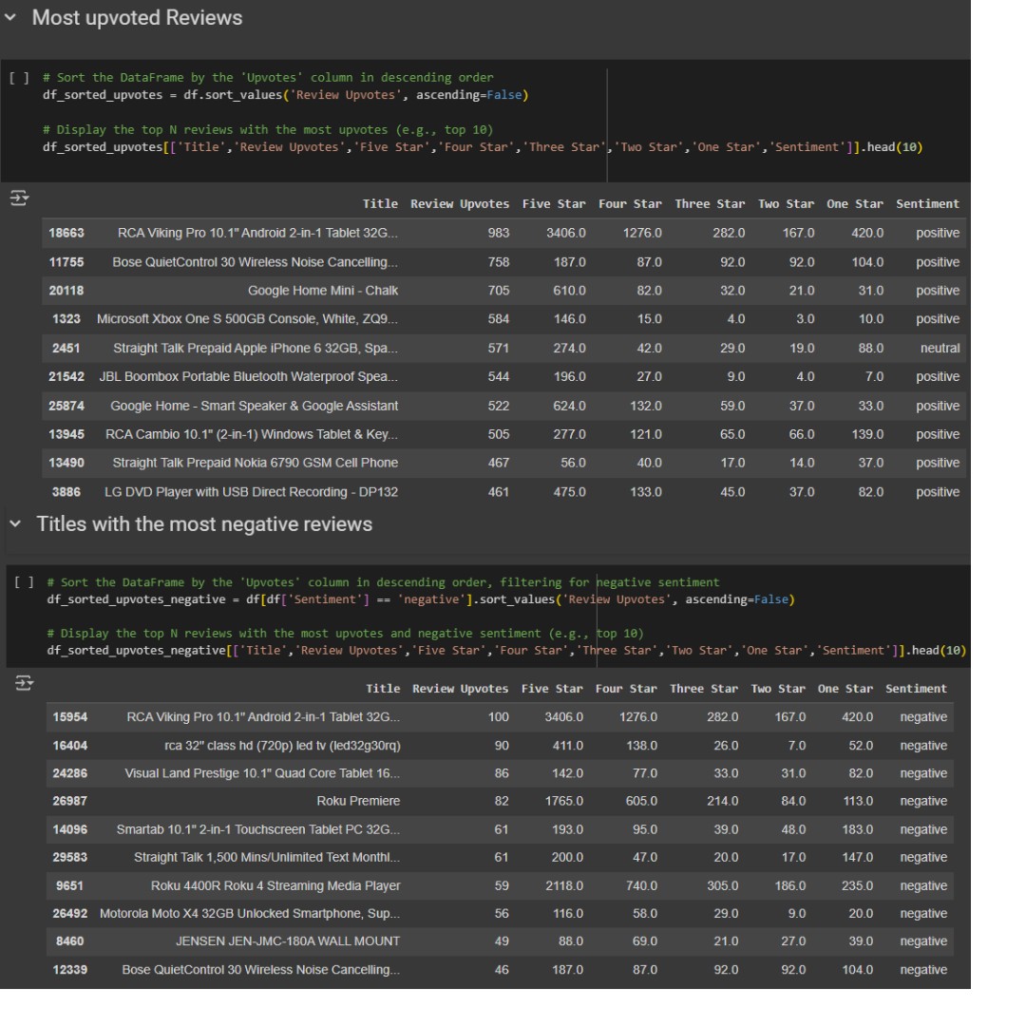

These two datasets can help us pinpoint specific products that are doing well or not so well when it comes to customer satisfaction. Showing all the positive or negative reviews for a product would be very tedious and difficult but seeing the top reviews can help us get a general customer sentiment of a product, as many customers may not necessarily write their own review but would still upvote a review they agree with. Interestingly enough the top product with the most reviews, the” RCA Viking Pro 10.1" Android 2-in-1 Tablet 32GB”, tops the positive and negative side. This can be a valuable insight as it informs us that while this product is popular, it has some features that leave a very negative impression on some reviewers. Doing a deep analysis on this particular product’s reviews could help pinpoint some of these features and increase customer satisfaction. We don’t necessarily want to base all our decisions on the single most popular reviews, but they would likely provide very valuable data in terms of overall sentiment. It is also worth considering the number of stars a product receives, though the RCA Viking pro has the most negative upvotes, it also has a ton of positive upvotes, far more than negative. The same should be said for the other products with negative upvotes, the products with a disproportionate amount of negativity could be considered for removal, but more insight should be gained first. For the positive end, looking at what the highly upvoted positive reviews could help affirm some of the sentiment keywords we were seeing as well as give us more specific insight, as well as making sure those products are available, and potentially stocking new products with similar features and qualities that the consumers like.

# Recommendations/Ethical Considerations

# Recommendations

## Proposal: **Electronics Home Entertainment Experience Platform (EHEEP)**

**Objective:** The Electronics Home Entertainment Experience Platform (EHEEP) will revolutionize Walmart’s electronics and home entertainment sector by leveraging predictive analytics to deliver personalized services for home entertainment or recommendations based on the customer’s preferences or interests. In return, this platform will position Walmart’s electronic and home entertainment at the forefront of the industry by using data-driven insight to help anticipate and fulfill each customer’s preferences, thereby outperforming our competitors.

**Project Overview:**

1. **Personalized Recommendations:** EHEEP will utilize predictive analytics to tailor content/product recommendation based on the consumer’s view patterns, previous electronic/home entertainment ratings, buying trends, subscriptions, and household status (single/married, households with or without children).
2. **Diverse Product Offerings:** The platform will incorporate predictive analytics to identify emerging technologies and popular brands based on the demographic segments. In return, the marketing team will be able to develop direct marketing material that aligns with that customer’s interests or market trends in electronics and home entertainment.
3. **Audience Segmentation and Targeting:** EHEEP will enable targeted marketing campaigns and promotions that are tailored to each customer’s current and predicted interests.
4. **Customer Retention:** EHEEP will develop prediction models to identify users who are at risk of disengaging in interest with Walmart’s electronics and home entertainment products. In return, the platform will implement retention strategies, such as exclusive offers or discounts in hopes of maintaining high satisfaction.
5. **Continuous Improvement and Feedback:** EHEEP will feature robust performance tracking mechanisms to monitor effectiveness of recommendations, product engagement, and user satisfaction. Continuous feedback and performance monitoring data will be used to refine predictive models and enhance customer experience.

**Expected Outcomes:**

The Electronics Home Entertainment Experience Platform (EHEEP) is expected to significantly enhance the customer experience with Walmart’s electronics and home entertainment products by enhancing user engagement, enabling Walmart to offer state-of-the-art technologies based on market trend, and offer direct marketing strategies. In return, we will be positioning Walmart as a leader in electronics and home entertainment based on predictive analytics.

# Ethical Considerations

Developing the Electronics Home Entertainment Experience Platform (EHEEP), there are several ethical considerations that will be addressed to ensure responsible and transparent use of data. Below are some key points to consider:

Privacy and Security:

* + Customer Consent: Ensure customers are informed and provide explicit consent for data collection and usage.
  + Data Protection: Implement robust security measures to protect customer data.
  + Anonymization: Using anonymization techniques to protect customer identification.

Transparency:

* + Usage: Clear communication on how customer data is used, stored, and shared.

Fairness and Non-Discrimination:

* + Eliminating Bias: Reviewing algorithms to ensure they don’t derive bias data based on demographics and other factors.

Minimization of Use:

* + Minimize Data: Collect only data that is necessary for personalized services or product recommendations.

Customer Autonomy:

* + Opt-Out Options: Provide customers with the option to opt out of data collection or personalized recommendations.

Marketing Practices:

* + Honest Marketing: Ensure marketing strategies don’t exploit vulnerable customers or create pressure to buy. Meanwhile, ensuring that promotional messages are not misleading.

Employment Impact:

* + Displacement: Due to automation and analytics, consider some positions to be discontinued.
  + Workforce Training: Training employees to adapt to new technologies and methodologies introduced by EHEEP.

Continuous Evaluation:

* + Ethical Review: Establish a framework for ongoing ethical assessments of the platform, involving stakeholders to ensure diverse perspectives.
  + Customer Feedback: Seek and respond to customer feedback regarding any ethical concerns related to EHEEP.

In return, Walmart will create a more trustworthy and responsible platform that respects the rights of their customers and promotes a more positive shopping experience with Walmart.

# Conclusion

In conclusion, our analysis of customer satisfaction in Walmart's electronics and home entertainment categories highlights several critical insights and actionable strategies. By employing sentiment analysis on consumer reviews, we found that the majority of customers express positive sentiments towards Walmart's offerings, particularly in the categories of televisions and streaming devices like Roku. However, concerns regarding product performance—specifically related to sound quality, battery life, and overall reliability—emerged as significant factors affecting customer satisfaction.

The proposed Electronics Home Entertainment Experience Platform (EHEEP) aims to address these concerns by leveraging predictive analytics to personalize customer experiences and improve product offerings. Ethical considerations regarding data privacy, transparency, and non-discrimination will be paramount in the platform's development to foster trust and ensure responsible usage of consumer data.

As Walmart continues to compete in the rapidly evolving electronics market, understanding and responding to customer needs will be vital. By implementing the EHEEP, Walmart can enhance customer engagement, tailor its marketing strategies, and ultimately position itself as a leader in the electronics retail sector.

# References

Cjhutto. (n.d.). GitHub - cjhutto/vaderSentiment: VADER Sentiment Analysis. VADER (Valence Aware Dictionary and sEntiment Reasoner) is a lexicon and rule-based sentiment analysis tool that is specifically attuned to sentiments expressed in social media, and works well on texts from other domains. GitHub. <https://github.com/cjhutto/vaderSentiment>

VADER sentiment analysis (with examples) | Hex. (n.d.). <https://hex.tech/use-cases/sentiment-analysis/vader-sentiment-analysis/>

Ai, S. (2022b, August 12). Sentiment Analysis Project — with traditional ML & NLP. Medium. <https://medium.com/@skillcate/sentiment-analysis-project-with-traditional-ml-nlp-349185bf98dd>

# Appendix

Code used for the project can be found [here](https://colab.research.google.com/drive/1JfcqwvXv0OQBUN5pslQuIQuK7qy8I3ib#scrollTo=h-JKFJ4r1rOh).

Location for the dataset can be found [here](https://data.world/promptcloud/walmart-product-listing-data-2020/workspace/file?filename=marketing_sample_for_walmart_com-walmart_com_product_reviews__20200101_20200331.zip).

VADER - Valence Aware Dictionary and sEntiment Reasoner) is a lexicon and rule-based sentiment analysis tool that is specifically attuned to sentiments expressed in social media.